# Change request log

# Team

Group #5 (Inam and Pervez)

# Change Request

[FEMR-208](https://teamfemr.atlassian.net/browse/FEMR-208): Encounter PDF not displaying amount of prescription dispensed

# Concept Location

Below table is to describe each step that we followed when performing concept location for this change request.

|  |  |  |
| --- | --- | --- |
| Step # | Description | Rationale |
| 1 | We ran the system | We Got PDF file for patient History |
| 2 | We interacted with the system: after logging in we click below one after another  1) Create a new patient in Triage 2) Prescribe them some medications in Medical. Make sure the amount is > 0 3) Dispense the prescriptions in Pharmacy (click Submit) 4) View the patients encounter summary by pulling their ID up in Triage and clicking "Patient History" on the bottom. 5) Select the encounter where the prescription was dispensed on the right. The dispensed prescription is displayed here with the amount. 6) Click the red "Generate PDF" button. | We saw amount beside the medicine in Dispensed Medication section in patient history previous encounters screen |
| 3 | It is a bug in a particular screen in UI  We searched for "PDControler" in UI controller folder. | Because we identified there is no any amount shown in Patient history PDF page in “Dispensed Medication section. |
| 4 | From search results, we got Edit View model class under “users” folder using the Structure window of the IDE. |  |
| 5 | We inspected the class PDFControler  and under that class, we got one public method called createPatientInfoTable of PdfPTable type | We noticed that the method has detail logic for creating pdf contents for patient history which is coming from UI patient history previous encounters |
| 6 | In UI, we have a small table with 2 columns for dispensed medication. First column contains amount and medicine name and second column contains replaced. | But unfortunately amount part is not displayed in PDF when you hit the “generate PDF” button. |

**Time spent (in minutes):** 120

# Impact Analysis

|  |  |  |
| --- | --- | --- |
| Step # | Description | Rationale |
| 1 | We changed createPatientInfoTable a method in “PDFControler” class | Edit User validate method handles validation of Each field in Edit User UI. |
| 2 | In the View Part, IndexEncounter.scala.html consumes PDFContoller class by passing patient ID and it took action by pressing Button | View Html calls the method createpatientinfotable in PDFcontroler class to generate the PDF contents for a patient. |
| 4 | No other class in that application used that class for any reason | No impact |

**Time spent (in minutes):** 330

# Actualization

Using the table below, describe each step you followed when changing the code. Include as many details as possible, including why classes/methods were modified, added, removed, renamed, etc.

|  |  |  |
| --- | --- | --- |
| Step # | Description | Rationale |
| 1 | We modified one method which creates the PDF contents for a patient. We added condition when medication name is not null and add a cell for amount by calling Table.AddCell() method. | We saw in PDF file extra one column is added for amount in dispensing medication section |
|  |  |  |

**Time spent (in minutes):** 50

# Validation

Using the table below, describe any validation activity (e.g., testing, code inspections, etc.) you performed for this change request. Include the description of each test case, the result (pass/fail) and its rationale.

|  |  |  |
| --- | --- | --- |
| Step # | Description | Rationale |
| 1 | Test Case:  Input sequence:  Create a new Patient in Triage tab and  add some treatment for his disease in medical Tab and  add in dispense the medicine in Pharmacy Tab  and again see patient history in Triage Tab.  Output:  In UI and PDF, Both place you can see amount in dispensing medication section in tabular format. | This is the regular expected behavior.  The test passed. |
| 4 |  |  |

**Time spent (in minutes):** 25

# 

# Timing

Summarize the time spent on each phase.

|  |  |
| --- | --- |
| Phase Name | Time (in minutes) |
| Concept location | 120 |
| Impact Analysis | 330 |
| Prefactoring | 0 |
| Actualization | 50 |
| Postfactoring | 0 |
| Verification | 25 |
| Total | 525 |

# Reverse engineering

# 

# 

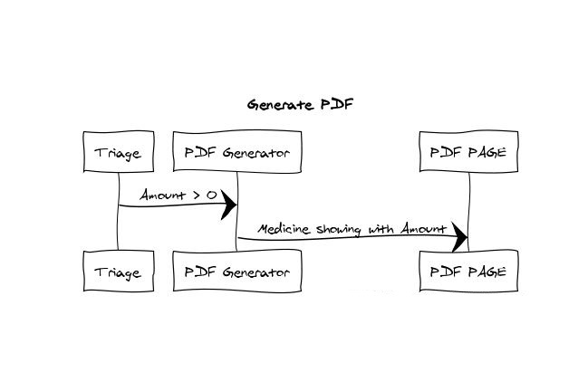

# Conclusions

Regarding this fix, we change below method from Controller PDFController class and there is no anywhere we used that method.

\workspace\femr\app\femr\ui\controllers PDFController.java

public PdfPTable createPatientInfoTable()